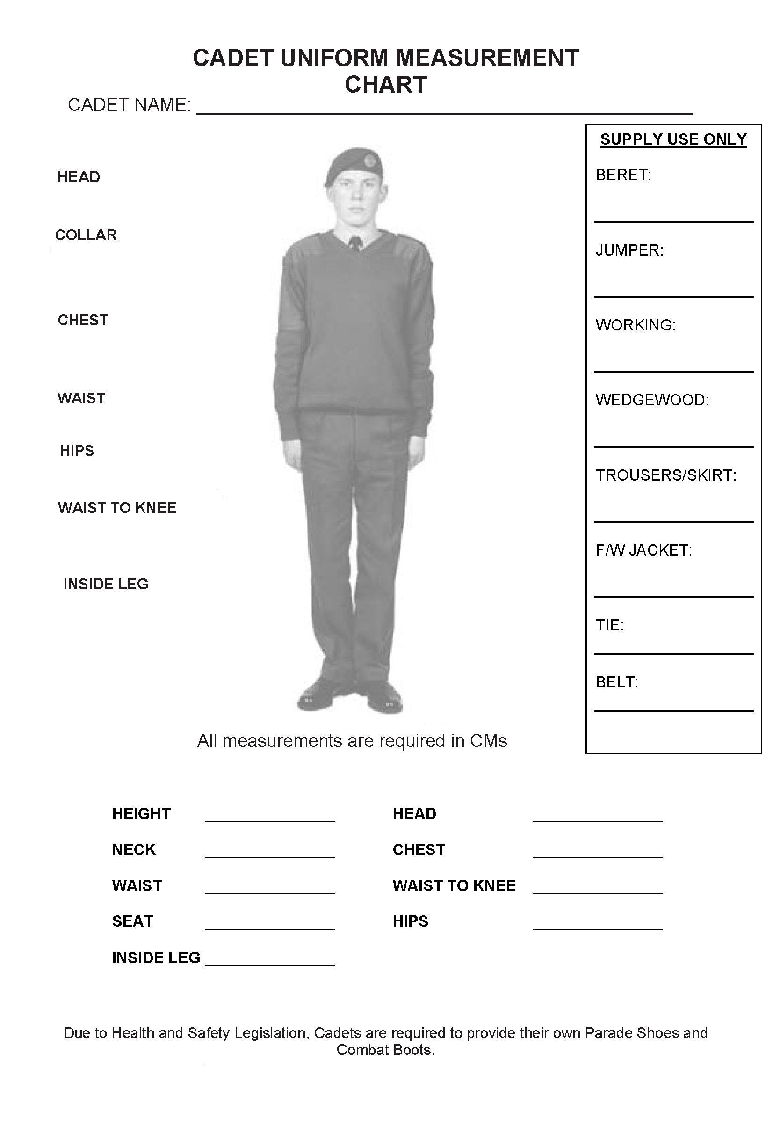
This form should be completed and returned to the NCO i/c RAF Stores where it will be filed for future use
DATE measurements taken:___________________________________________________________

